Curriculum Vitae
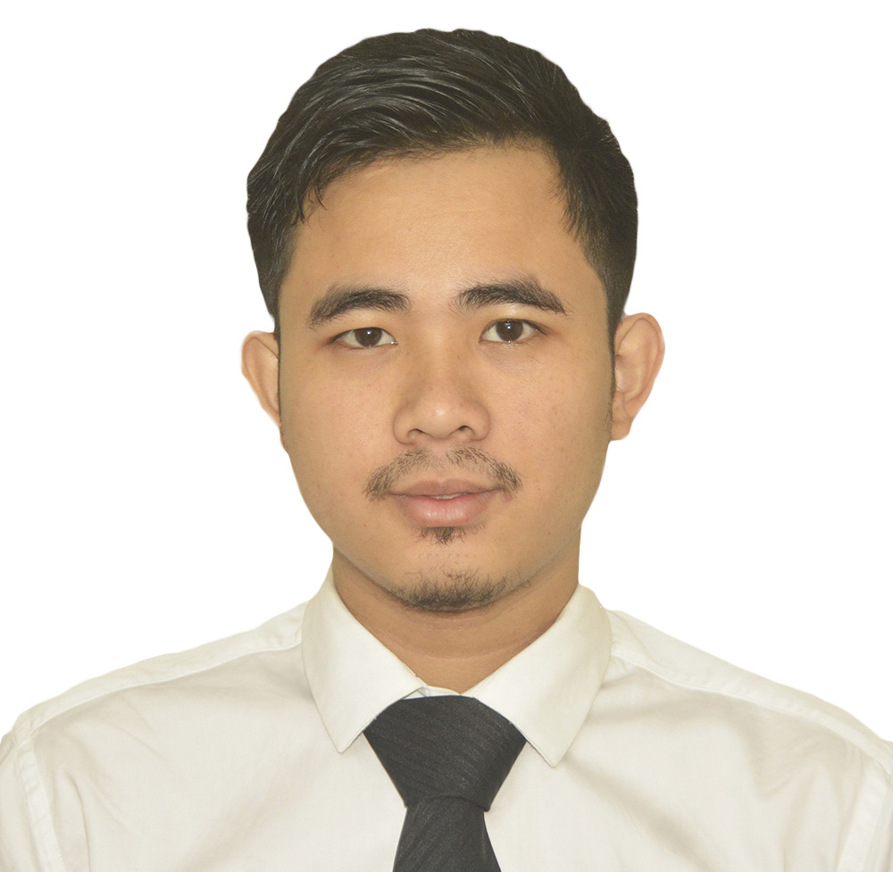
MANORAM CHAKMA
Current Address: House, 226, West Shewrapara, Mirpur, Dhaka-1216
Phone: 01704532342, E-mail: chakmamanoram@gmail.com

Career Objective:

To obtain a position where my potentials, leadership, business, communication and analytical skills are challenged and utilized. So that i can constantly develop my knowledge.
Special Qualification:

- Competent at managing responsibilities in a high-volume atmosphere
- Hard worker, quick learner and ability to assume responsibility
- Polite, respectful and courteous manners
- Work well under pressure to meet deadlines
- Take right decision in any adverse situation
- I have the potential to work in a team.
Skills & Expertise:
Adobe Photoshop, Video Editing, Cinematography, Photography.
MS (word, excel, power point), E-mail transaction.

Extra Curriculum Activities:

Good Coordinating & Management skills, and have also good knowledge in event management.

Employment History:

Worked at Maxim Label & Packaging (Bangladesh) Private Limited as a customer support executive from 17th July 2017 to 31st oct 2017.

Responsibility:
- Prepare performance invoice (PI) and send it to vendor through email
- Maintain and update garment accessory's order management and processing
- Vendor maintenance and management
- Labor maintenance

Worked at Pathao as a customer support officer (Complain Department) from 3rd December 2017 to 30th June 2019

Responsibility:
- Initiated and created complain reply modality in Zendesk
- Follow up customer and deliveryman by email through Zendesk
- Investigate fraudulent activities
- Solved Food order and bill related problems in back office tools

Working at Redx as a Hub Supervisor since 30th December 2020

Responsibility:
- Routing Delivery Man
- Assign parcel to delivery man
- Cash collection from delivery man
- Make daily payment to HQ
- Solve any kind of issue in hub

Academic Qualifications:
Masters in Customs Administration
University Of International Business and Economics (Beijing)
Expecting to complete the course in June 2021(Online)
Bachelor of Business Administration (BBA)
Savitribai Phule Pune University
Major in Marketing with 2nd class
Higher Secondary Certificate (HSC)
Khagrachari Cantonment Public School & College
Humanities, GPA-4.20
Secondary School Certificate (SSC)
Khagrachari Govt High School
Science, GPA-4.13

Language Proficiency:
English : Reading-High, Writing-Medium, Speaking-Medium
Bangla : Reading-Native, Writing- Native, Speaking- Native
Hindi : Reading- N/A, Writing- N/A, Speaking- High

Hobbies & Interests:

Photography, Cooking, Cinematography, watching movies and travelling etc.

Personal Details:

National ID : 3706193186
Date of Birth : 11th Oct 1993
Permanent address : Jamtoli, Khagrachori, Chittagong, Bangladesh

Declaration:

It is sincerely acknowledged by me that above all information’s about me is true and correct.
Reference:

Dr. Vishwas Swami Ishteak Tofazzal
Head of the department Marketing Sales Supervisor at
Business Administration Maxim Label & Packaging (Bangladesh)
Sinhgad College of Commerce Private Limited
(Affiliated to Savitribai Phule Pune University) E-mail: Isteak08@gmail.com
E-mail:vishwasswami.scoc@sinhgad.edu Mobile:+8801717474819 Mobile: +919371183914

Signature:

Manoram Chakma

